**1. Dropdowns**

1.1 Dropdown

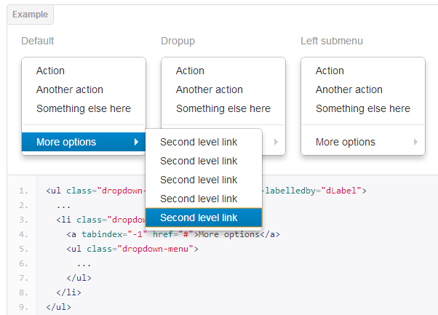

1.2 Dropup

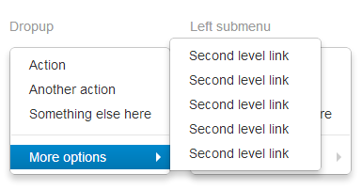

1.3 Left submenu

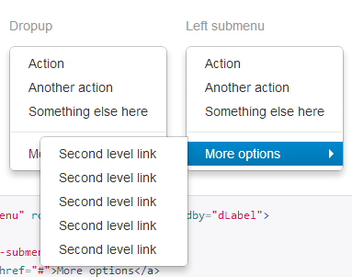

**2. Button groups**

* 1. Single button groups

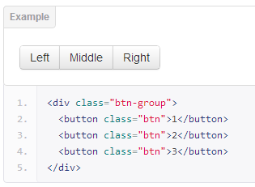

* 1. Multiple button groups

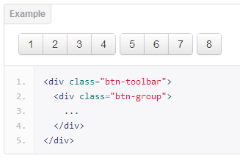

2.3 Vertical button groups

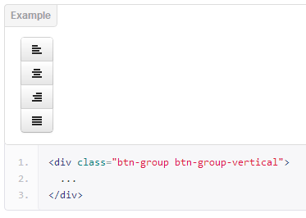

**3. Button dropdown**

3.1 button dropdown menus

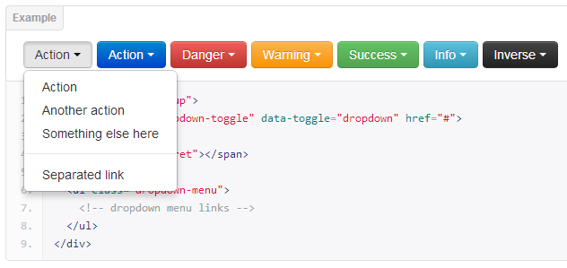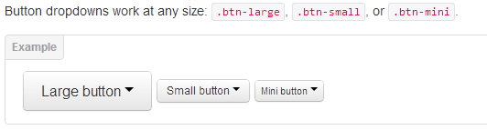

3.2 Split button dropdowns

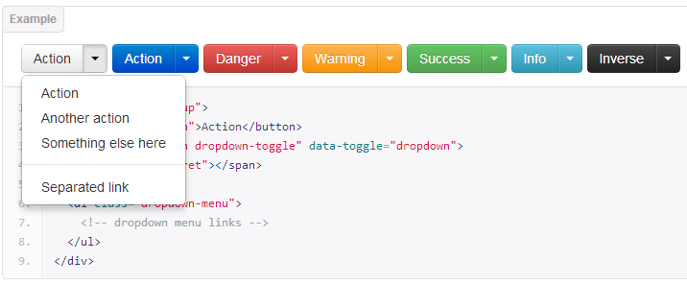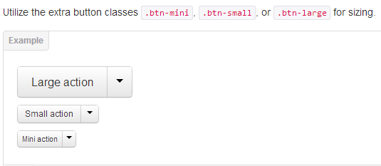

3.3 Dropup menus

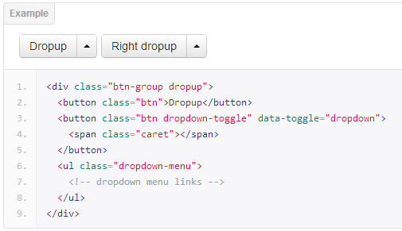

**4.** Navs

4.1 Basic tabs

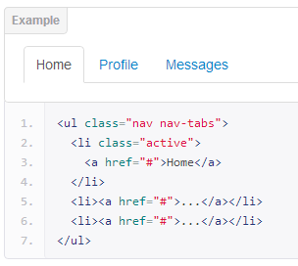

4.2 Basic pills

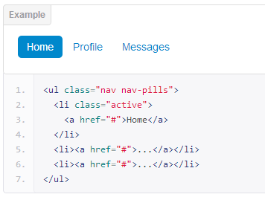

4.3 Disabled state

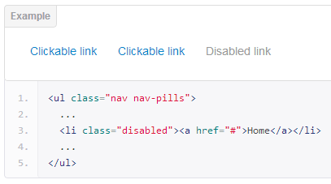

4.4 Stacked tabs

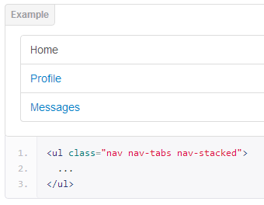

4.5 Stacked pills

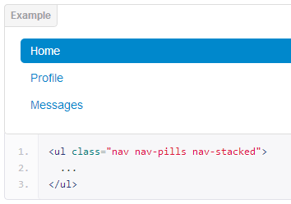

4.6 Tab with downdrops

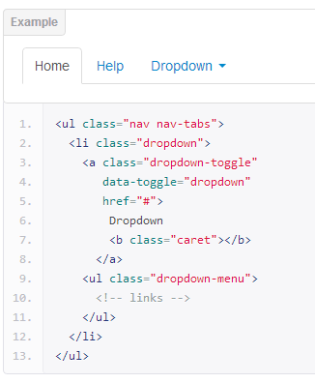

4.7 Pills with dropdowns

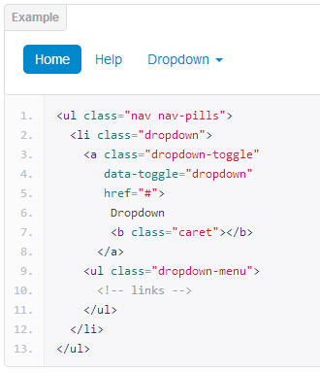

4.8 Nav lists

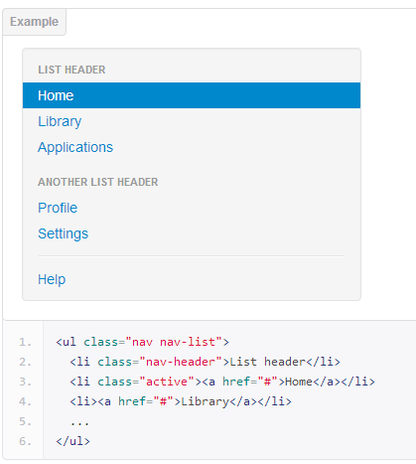

4.9 Tabbable nav

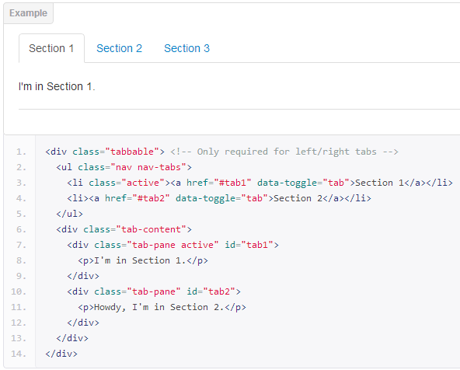

4.10 Tabs on bottom

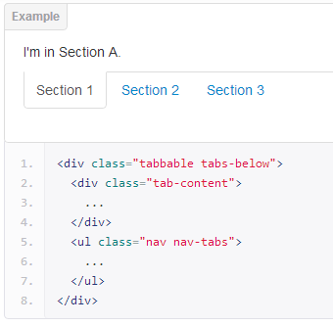

4.11 Tabs on left

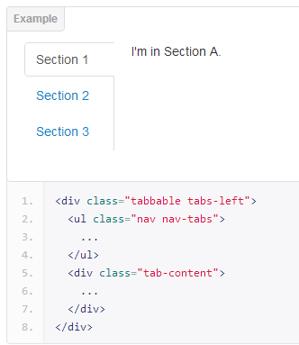

4.12 Tabs on right

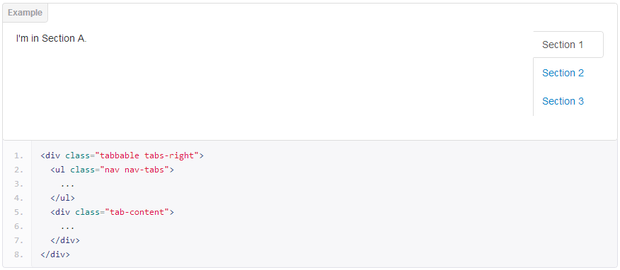

**5. Navbar**

5.1. Basic navbar

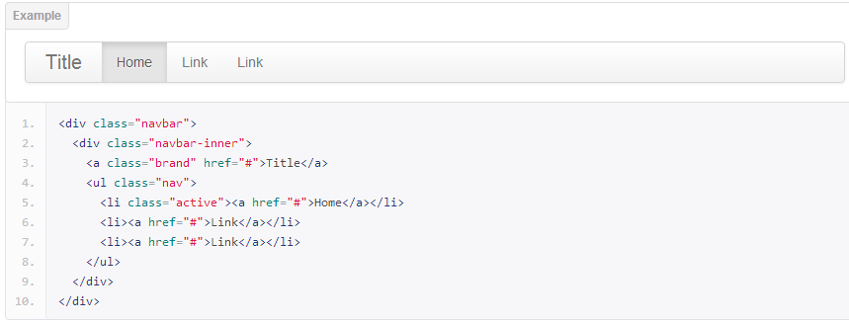

5.2 Nav links

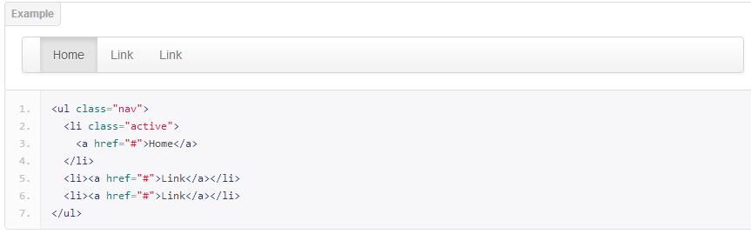

5.3 Form

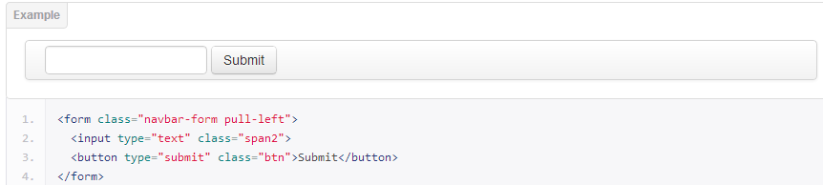

5.4 Search form

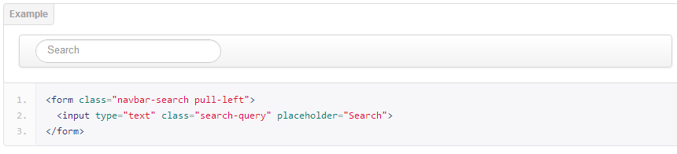

5.5 Inverted variation

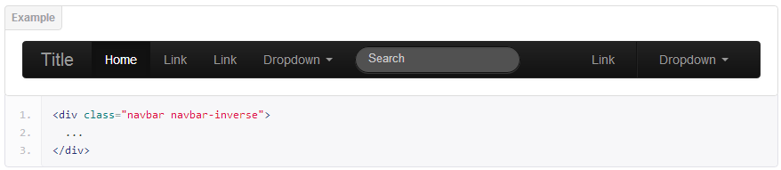

**6. Breadcrums**

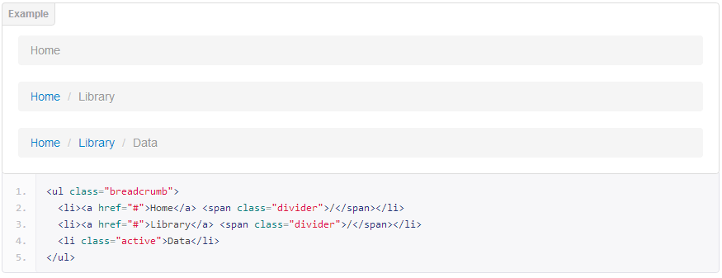

**7. Pagination**

7.1 Standard